**INSIGHTS AND QUESTIONS:**

1. **Which users have contributed the most in terms of comments, edits, and votes?**

**QUERY:**

select count(`text`) as comments,

user_id

from comments

group by user_id;

**RESULTS:**

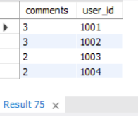

**INSIGHTS:**

The data is insufficient according to the question because the votes tables doesn`t have any direct relationship between the user table, and the edit column does not exist in any table so the relationship between these columns can not be justified, however according to the comments table user 1001 and 1002 have contributed the most the the comments with no of comments 3.

1. **What types of badges are most commonly earned, and which users are the top earners?**

**Query:**

**For most common badges:**

select count(id) as no_of_badges, `name`

from badges

group by `name`;

**For top earners:**

select count(`name`) as top_earner, user_id

from badges

group by user_id;

**Results:**

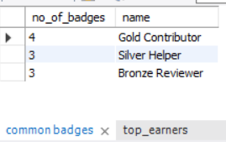 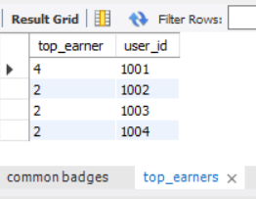

**INSIGHTS:**

According to the insights the user “1001” earned the 4 badges that makes him the top earner and badge “GOLD CONTRIBUTOR” is the most common badge in the table that appears for 4 times in the table.

1. **Which tags are associated with the highest-scoring posts?**

There is no direct relationship between tags and posts table as the primary key of posts or tag table doesn't exist in the other table as a foreign key, therefore there are no common values and joins can`t be applied on them. So the query does not justify the data given in the dataset.

1. **How often are related questions linked, and what does this say about knowledge sharing?**

**Query:**

select post_id , title,

count(related_post_id) as linked_question

from post_links a

join posts b on a.post_id = b.id

group by post_id ;

Result:

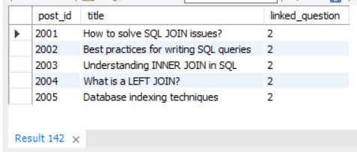

**INSIGHTS:**

The results show that the linked_question or related posts for 5 post_id appears for 2 times, which shows that the audience is interested in posts that cover basics of sql and joins because this is the major part of the sql.